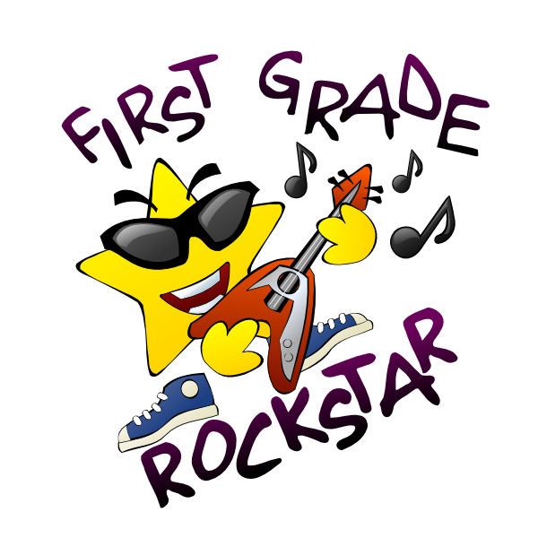

**HENRY J. KALFAS ELEMENTARY SCHOOL**

**FIRST GRADE SUPPLY LIST**

1 Backpack without wheels

1 pencil/ crayon box

1 Box of Gallon-sized Ziploc Bags

1 Blue Pocket folder with 3 prongs

1 Box of sandwich-sized Ziploc bags

1 Bottle of Hand Sanitizer

1 Container Clorox Wipes

1 Box Crayons 24 count

2 Boxes Kleenex

2 Sturdy pocket folders for take home work (plastic is best)

** IN AN EFFORT TO KEEP EVERYONE’S BELONGINGS SEPARATED AND ORGANIZED, WE WOULD APPRECIATE IT IF YOU COULD PLEASE LABEL YOUR CHILD’S SUPPLIES WITH HIS OR HER NAME IN PERMANENT MARKER PRIOR TO THE 1ST DAY OF SCHOOL**